# SettingupApplicationEnvironmentCreateSendgridAccount

**Step1.**Navigatetohttps://sendgrid.com

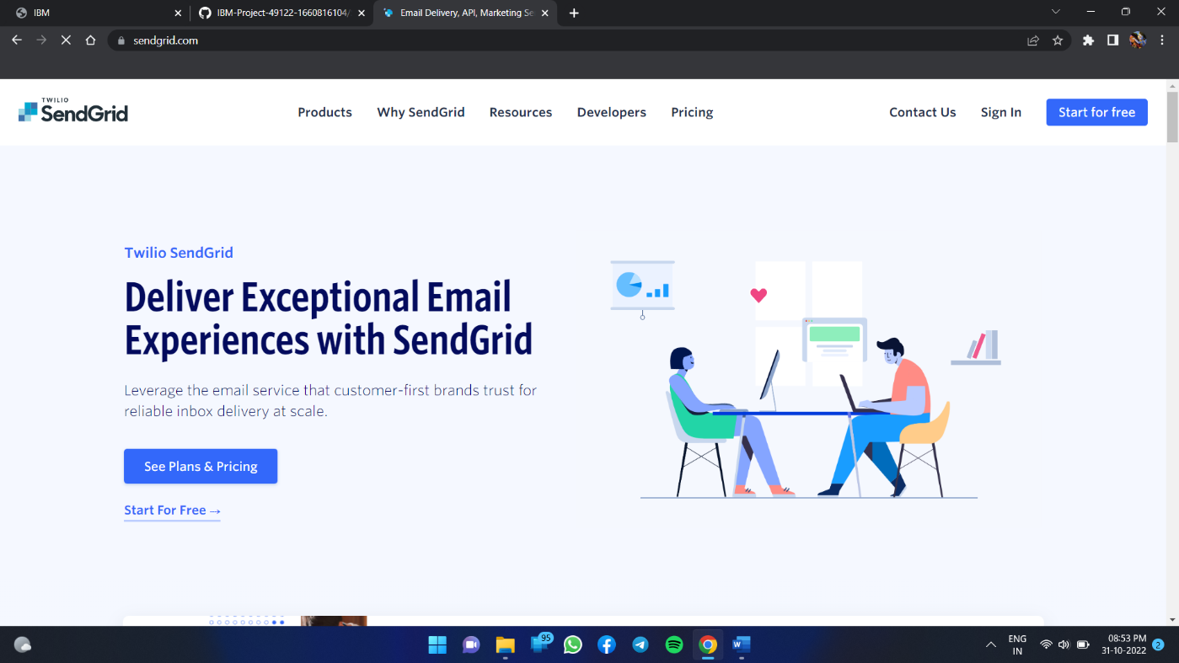

**Step2.**Clickon“Startforfree”andregisteryourselvesbyenteringrequireddetailsandclickoncreateaccount

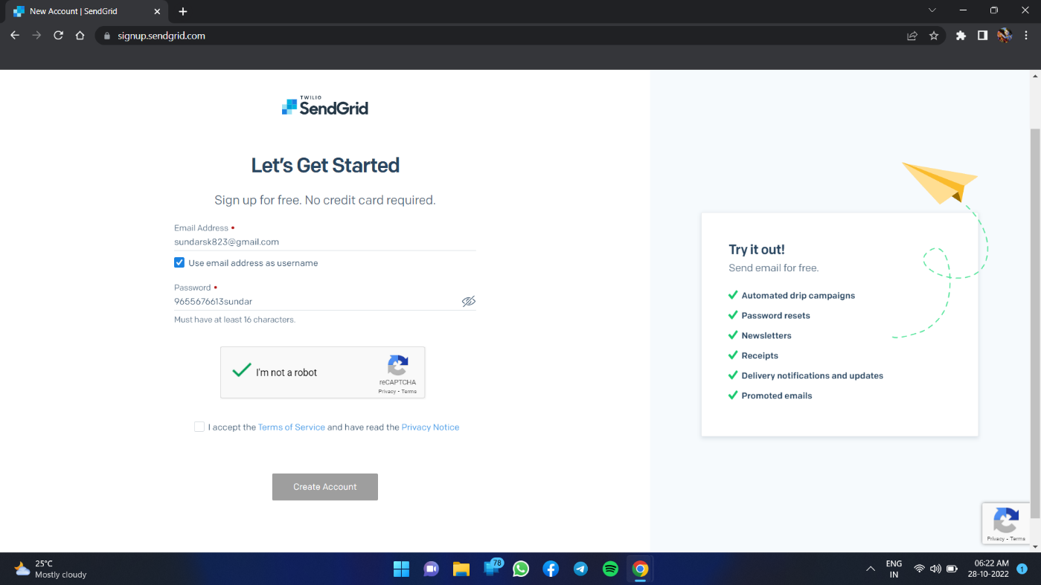

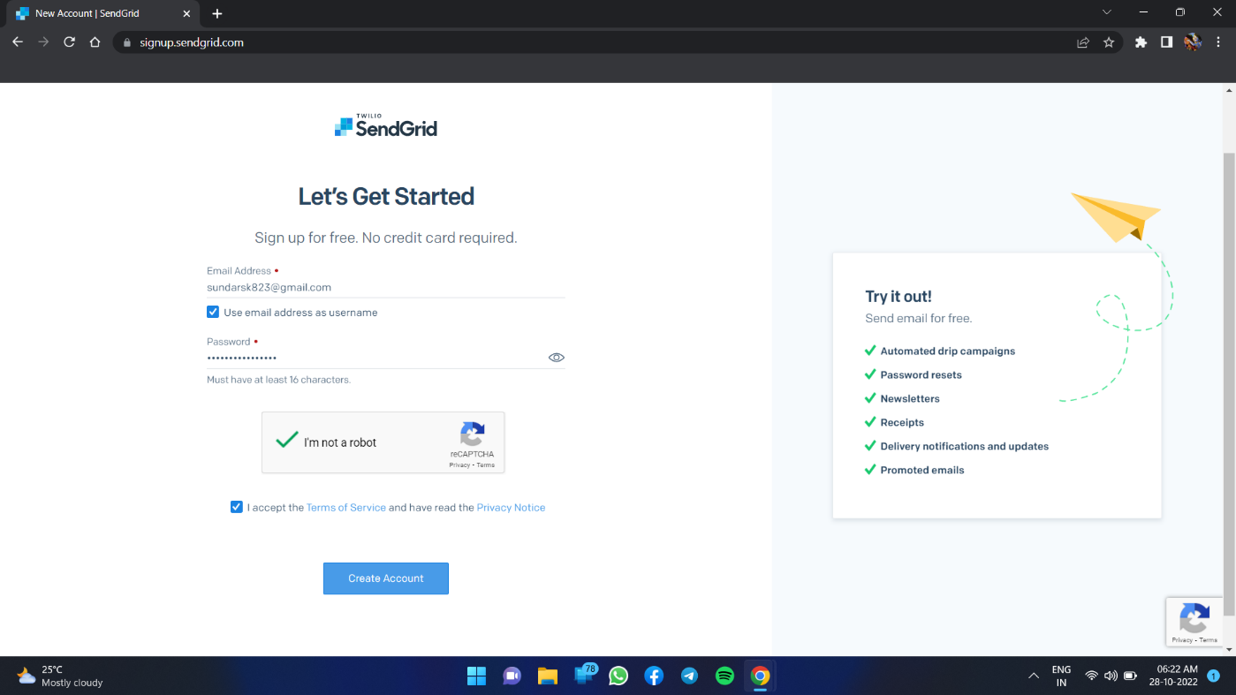

**Step3.**Furtherfillallrequireddetailsinnextpageandclickongetstartedasshownbelow

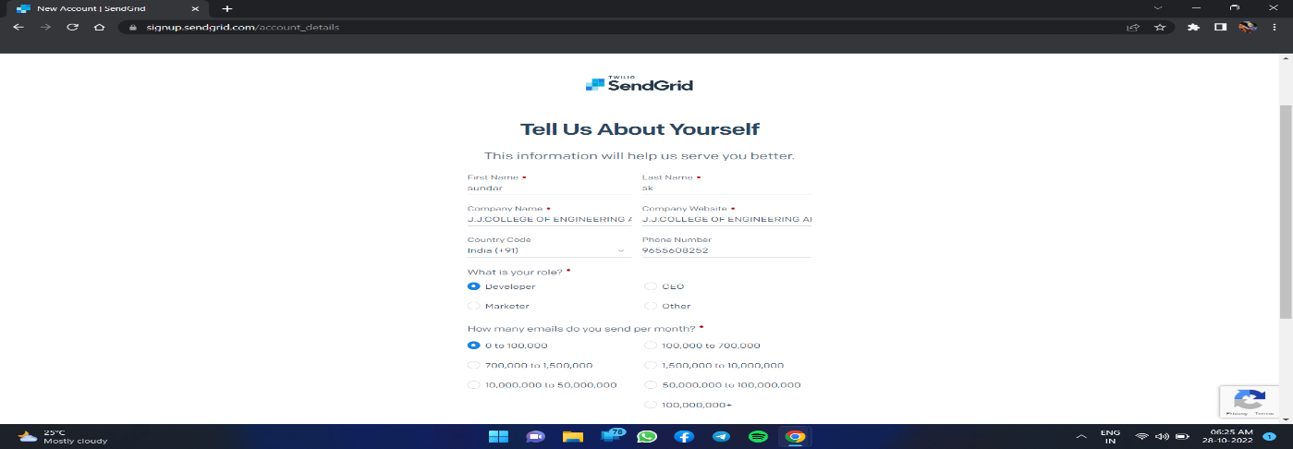

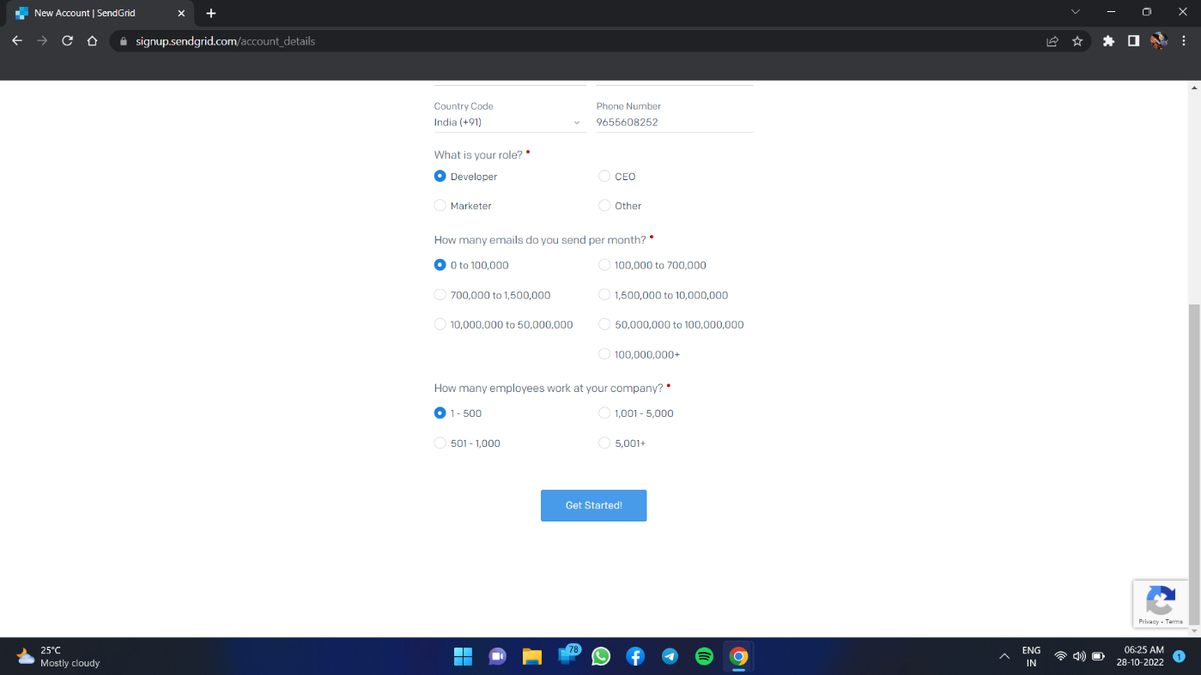

**Step 4.** That’sityou have createdyour SendGrid accountand gotaccesstodashboard

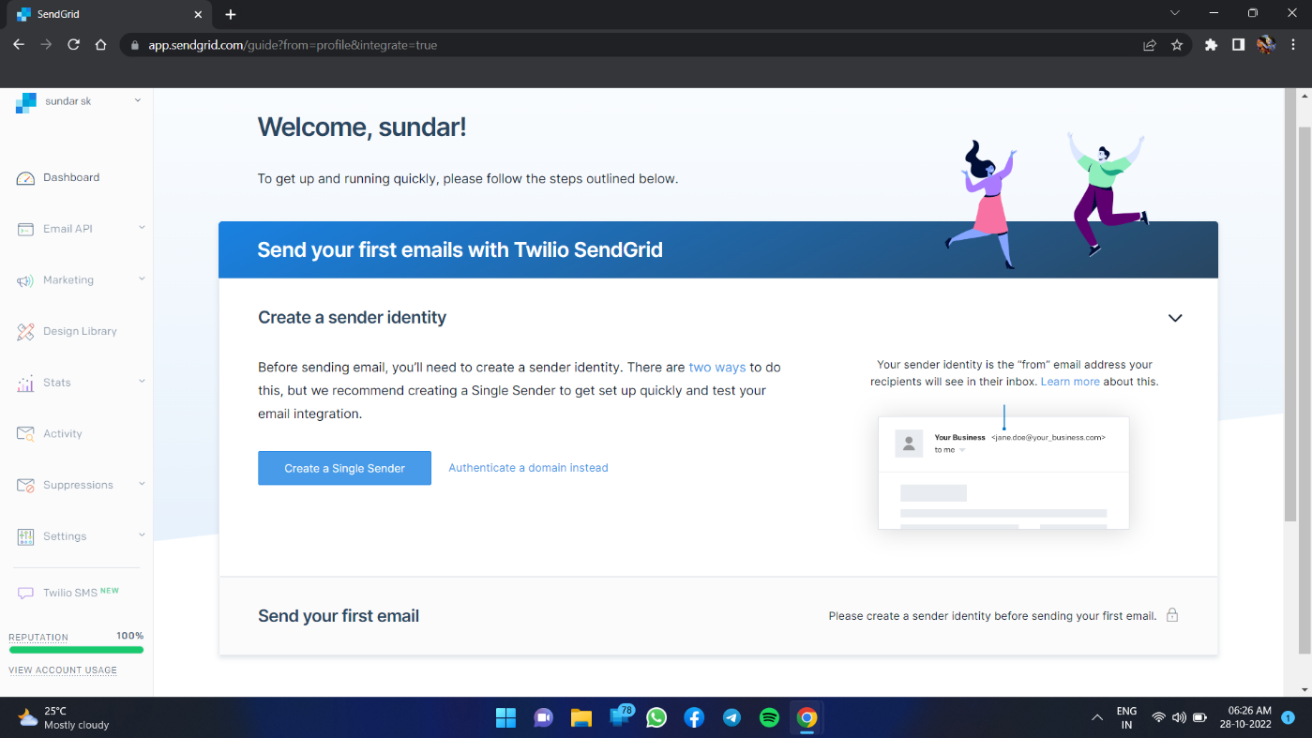

# Output:

SendGridaccountcreatedsuccessfully.